**ELECTRIC VEHICLE MARKET SEGMENTATION ANALYSIS**

Kalyan Kumar Marella

August 18,2024

GitHub Link: [Project Github Link](https://github.com/KalyanMarella/Feynn_Labs_Internship/blob/main/EV_Market_Segmentation.ipynb)

*Abstract*

This project presents a comprehensive analysis of India's electric vehicle market, focusing on segmentation derived from sales data, customer reviews, and technical specifications. The study highlights the robust growth trajectory of India's two-wheeler market, establishing it as a primary revenue source. Utilizing behavioral variables from customer reviews, a rigorous market segmentation analysis was conducted employing the standard k-means algorithm. The analysis effectively partitioned the market into four distinct segments.

Segment 1 emerges as the cornerstone of our strategy, constituting a substantial 39% of the consumer base. This segment not only represents a substantial market opportunity but also serves as the optimal target for our venture. The analysis guides the recommendation of specific electric two-wheeler technical specifications tailored to meet the preferences of Segment 1 consumers.

The recommended specifications, seamlessly integrating with the demands of this segment, are pivotal to our approach. Moreover, the price range aligns closely with the median values, ensuring affordability and competitiveness. This strategic alignment with Segment 1, identified as the potential early market customer base, positions our venture optimally within India's electric vehicle landscape.

**1.0 Introduction**

India is experiencing a significant shift in its transportation landscape, driven by the widespread adoption of Electric Vehicles (EVs). The nation's rapid urbanization, growing population, and increased income levels have fueled the embrace of EVs as an eco-friendly alternative. Among these, electric two-wheelers have emerged as pioneers due to their affordability and wide consumer acceptance. These vehicles are reshaping India's mobility narrative, offering a sustainable solution to the challenges of pollution and greenhouse gas emissions.

The Indian government has played a vital role in fostering this change, implementing policies that encourage local manufacturing and support a robust network of manufacturers, dealers, and service providers. In 2023, the electric two-wheeler market in India has reached a pinnacle, symbolizing the success of these efforts and the growing acceptance of clean mobility solutions.

This study delves into the heart of this transformation, focusing on the electric vehicle industry with a specific emphasis on electric two-wheelers. By combining behavioral segments, psychographic data, and detailed vehicle specifications, we provide informed EV price recommendations. This holistic approach aims to empower consumers, policymakers, and industry stakeholders alike. By understanding the diverse facets of consumer behavior and preferences, this study illuminates the path toward a sustainable, environmentally conscious, and consumer-centric electric transportation system in India.

**2.0 Problem Statement and Fermi Estimation**

**2.1 Problem Statement**

The challenge at hand is to strategically position our Electric Vehicle Startup in the Indian market by utilizing data-driven insights derived from sales data, customer reviews (encompassing behavioral and psychographic data), and technical specifications of electric vehicles. Our objective is to employ these insights to effectively segment the market and recommend target segments for our electric vehicles.

**2.2 Fermi Estimation**

**2.2.1 Data Collection and Assessment**

* Gather sales data, electric vehicle customer reviews, and technical specifications.
* Evaluate the reliability and comprehensiveness of the collected data.

**2.2.2 Segmentation Using Behavioral Variables**

* Utilize behavioral data to identify patterns and segments within the customer base.
* Estimate the size and characteristics of each segment using data-driven techniques.

**2.2.3 Analysis of Psychographic Data**

* Analyze psychographic data within each behavioral segment to discern customer preferences and motivations.
* Estimate the psychographic traits and preferences of customers within each segment.

**2.2.4 Technical Specification and Price Analysis**

* Evaluate technical specifications of electric vehicles within identified segments.
* Estimate the impact of technical features on customer preferences and purchasing decisions.

**2.2.5 Target Segment Selection**

* Select target segments based on a thorough analysis of behavioral, psychographic, and technical factors.

**2.2.6 Customization of Marketing Mix**

* Develop a customized marketing mix tailored specifically for the selected target segments.
* Estimate the effectiveness of various marketing strategies within the selected target segments, aligning them with customer preferences.

**2.2.7 Segment Recommendation**

* Combine segment analysis results and marketing mix customization findings to finalize segment recommendations.
* Recommend target segments with the highest estimated market potential, ensuring a focused and targeted market entry strategy.

By following these systematic steps, employing Fermi estimation at each stage, our Electric Vehicle Startup aims to make informed decisions, precisely target market segments, and tailor our marketing approach to meet the unique demands and preferences of our customers, ensuring a successful market entry and sustained growth.

**3.0 Data Sources and Collection**

For this project, data was gathered from three distinct sources. The primary dataset, obtained from the Society of Manufacturers of Electric Vehicles, spanning 2017 to 2023, catalogues sales figures of electric two-wheelers, three-wheelers, four-wheelers, and buses. This dataset provides a comprehensive view of market trends and customer preferences over time.

The second dataset, extracted from bikewale.com, comprises electric two-wheeler customer reviews, offering vital behavioural and psychographic insights. These qualitative inputs proved invaluable in understanding customer behaviour.

Lastly, the third dataset from bikewale.com presents detailed technical specifications and pricing information of electric two-wheelers. This data allowed us to assess the technical feasibility and price points crucial for our market segmentation strategy.

By integrating these datasets, a robust understanding of the electric vehicle market was developed. Real sales data, customer sentiments, and technical specifics formed the foundation of our analysis, ensuring a data-driven, market-relevant segmentation approach.

**4.0 Data Pre-processing**

The data pre-processing phase of this project involved a systematic approach facilitated by Python libraries including NumPy, pandas, matplotlib, seaborn, and nltk. The first task was handling the sales data, initially distributed across 10 separate sheets in Excel format. Utilizing pandas, the data sheets were merged into a unified dataset, setting the foundation for subsequent analysis. A key focus was placed on ensuring the accuracy of electric vehicle maker names, achieved through meticulous replacement operations.

Following the data consolidation, essential aggregation operations were performed on electric two-wheeler sales data. This step provided a detailed perspective on market trends. The subsequent phase centred on data preparation for market segmentation. Customer reviews and responses were merged with corresponding electric vehicle technical specifications. To maintain data integrity, null values were handled using specific logical values, ensuring a complete dataset.

Sentiment analysis of customer reviews was conducted using the natural language processing capabilities of nltk. This analysis provided valuable qualitative insights into customer sentiments. Subsequently, behavioural variables such as Visual Appeal, Reliability, Performance, Service Experience, Extra Features, Comfort, Maintenance Cost, and Value for Money were isolated and meticulously prepared. These variables were fundamental in laying the groundwork for the market segmentation analysis, providing a nuanced understanding of customer preferences and attitudes toward electric vehicles.

**5.0 Segment Extraction**

**5.1 Using Sales Data**

In this segment, a detailed analysis was conducted based on three significant figures representing India's electric vehicle market.

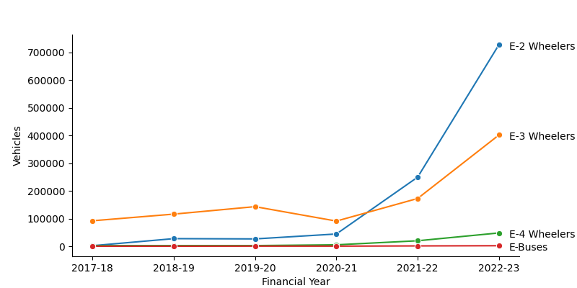

Above plotshowcased the remarkable growth trajectory of India's two-wheeler market in 2023, underscoring its leading position within the industry.

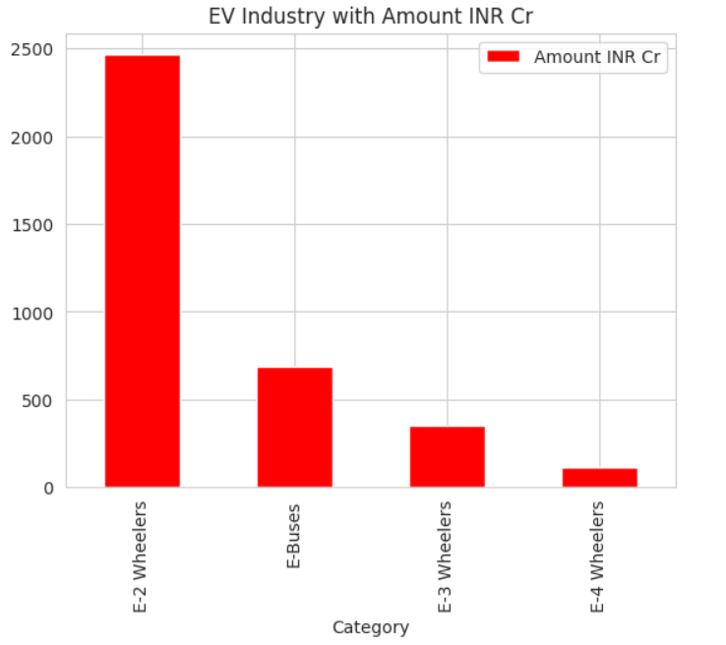

Above plot delved into the market's financial perspective, representing the industry's total value in crores. Notably, two-wheelers emerged as the primary revenue generators, highlighting their economic significance.

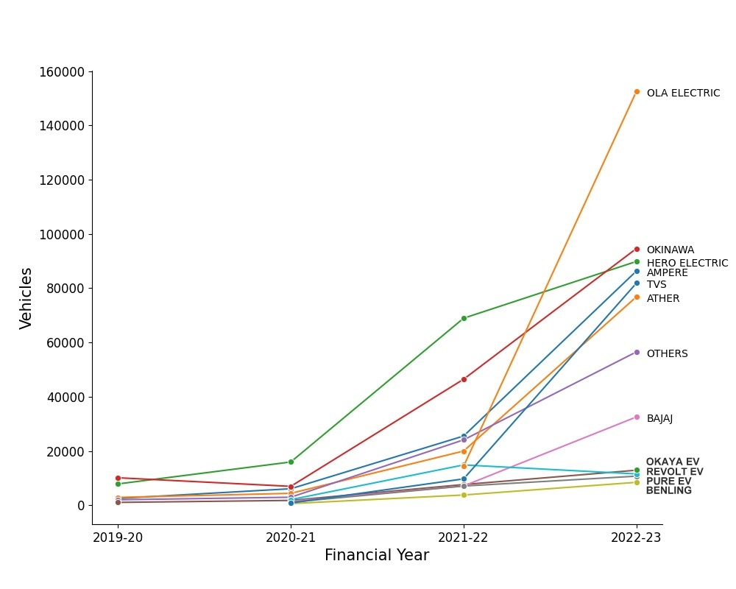

Above plot honed in on specific electric two-wheeler companies, with Ola Electric emerging as the market leader in 2023, illustrating industry leadership and market competitiveness.

Upon in-depth analysis of these figures, it became evident that the electric two-wheeler segment was the most promising area for our detailed study. The robust growth, revenue dominance, and market leadership collectively indicated its prominence and potential, making it the ideal focus for our detailed study.

**5.2 Using k-Means**

In this subsequent analysis, the standard k-means algorithm was applied to explore market segmentation possibilities within the electric two-wheeler customer reviews data. Solutions were systematically tested for two to eight market segments. The decision-making process was significantly guided by the scree plot Figure 5.4, revealing a distinct elbow at four segments. This marked point indicated a substantial reduction in distances, signifying the optimal number of segments for our analysis. By incorporating insights from these analyses, our focus remained finely tuned on the electric two-wheeler segment, ensuring precision and relevance in our market segmentation approach.

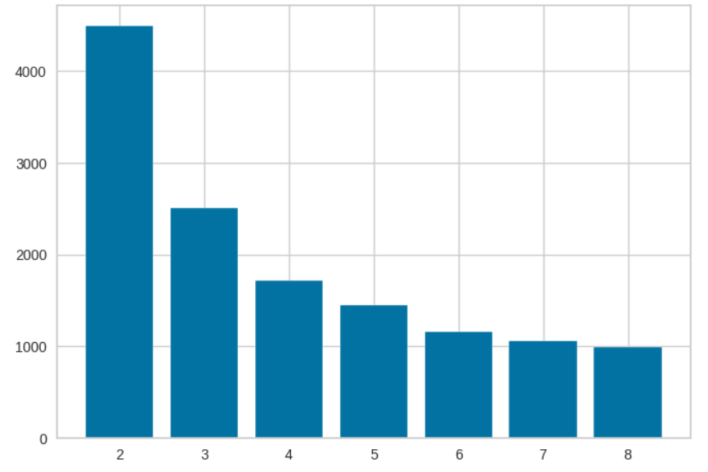

**6.0 Profiling and Describing Segmentation**

**6.1 Profiling Segments**

This section presents a detailed analysis of our consumer segments, as illustrated in the below plot

The graph visually captures the diverse perceptions among different segments. Segment 0, representing 32% of consumers, values the electric two-wheeler vehicle for its visual appeal, reliability, performance, service experience, and comfort. Conversely, Segment 1 (39% of consumers) expresses dissatisfaction across all aspects, marking them as the largest but least satisfied group. Segment 3 (15% of consumers) appreciates visual appeal, reliability, service experience, comfort, and notably, perceives a strong value for money. Lastly, Segment 2 (13% of consumers), the smallest segment, values visual appeal, reliability, performance, service experience, extra features, and maintenance cost, showcasing distinct perceptions, particularly on features and costs.

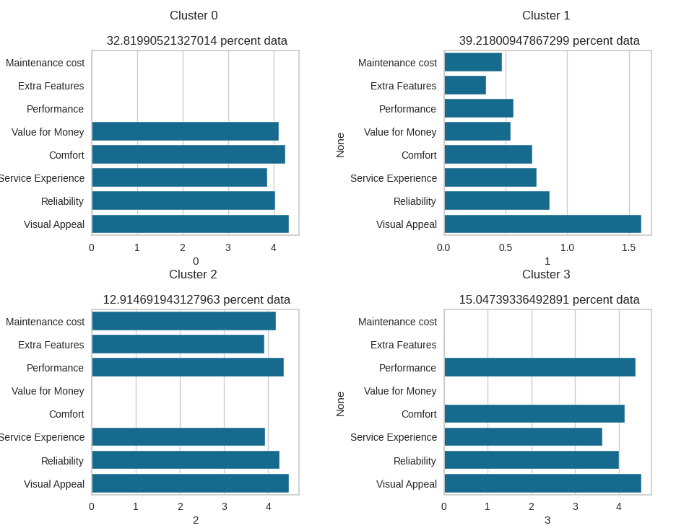

Utilizing principal components, further emphasizes these differences. Notably, Segment 1, despite being the largest segment, lacks specific opinions, making them unique in their lack of satisfaction. These detailed insights play a pivotal role in shaping our strategy, ensuring our electric vehicles align precisely with the diverse values and priorities of each segment, thus informing our market offerings accurately.

**6.2 Describing Segments**

This section provides a comprehensive overview based on the insights derived from various mosaic plots and graphical representations.

First plot shows Segments predominantly use electric vehicles for daily commuting, with limited usage for tours, occasional commuting, and leisure rides.

Next plot delineates the ownership duration of electric vehicles among segments. Segment 1 stands out, owning electric vehicles for more than a year, while Segment 3 has no prior ownership experience. Segment 2 members moderately own vehicles ranging from less than 3 months to over a year, and Segment 0 consumers have owned electric vehicles for a few days to less than 3 months.

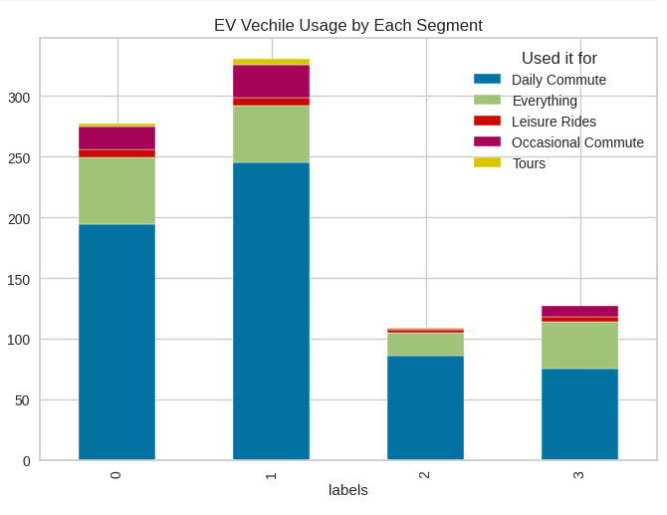

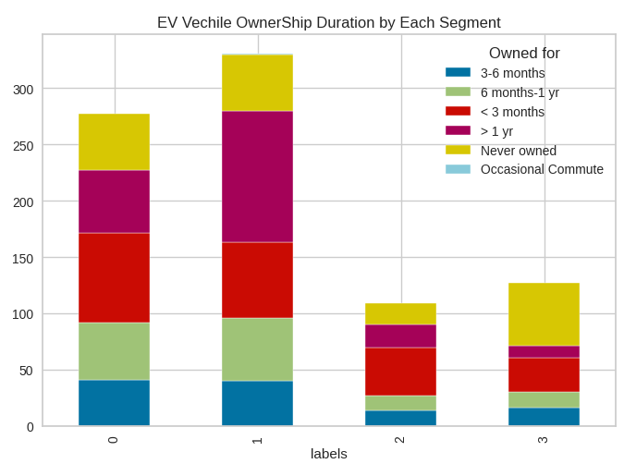

Below delves into the distances covered by consumers, indicating that all segments predominantly use electric vehicles for commuting, with most users covering distances below 5000 kms. A small portion falls in the 5000 to 10000 kms range, aligning with their commuting needs.

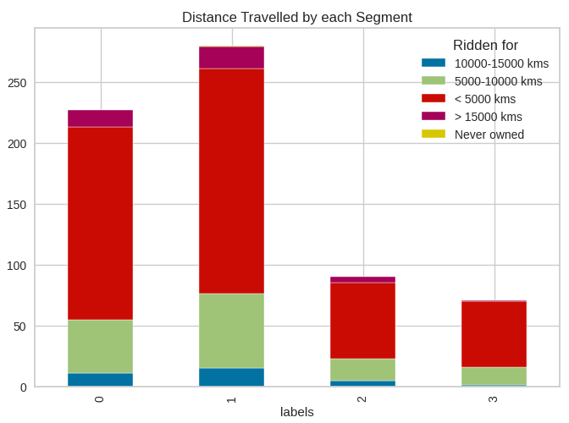

Below explores consumer sentiments, revealing that all segments, except Segment 1, exhibit positive sentiments. Segment 1 consumers stand out with negative sentiments, indicating dissatisfaction across various aspects.

Next plots, emphasizes significant differences in average ratings among segments. Specifically, Segment 1 consumers express dissatisfaction across all perceptions, leading to lower overall ratings. These graphical representations offer nuanced insights into consumer behaviours, sentiments, and preferences, guiding our strategic decisions for a more tailored approach in the electric vehicle market.

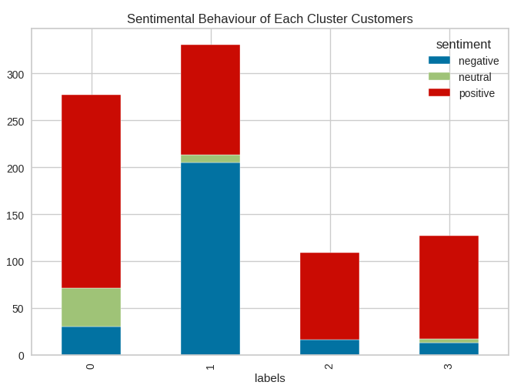

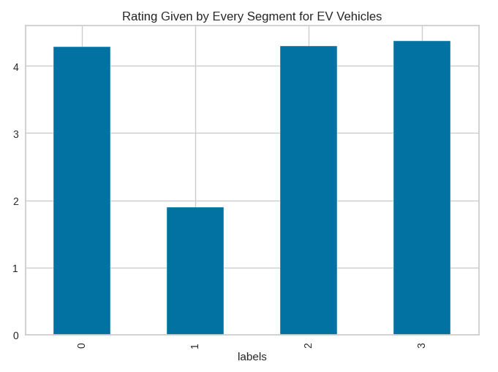

|  |  |
| --- | --- |
|  |  |
|  |  |
|  |  |

**7.0 Selection of Target Segment**

In the strategic selection of our target segment for the electric vehicle market, Segment 1 and Segment 0 stand out as potential focal points. Segment 1, encompassing 39% of consumers, represents a vast market base with diverse perceptions and preferences. This segment's varying sentiments, as revealed through our analysis, signify their specific demands and priorities. Understanding their unique perceptions, such as dissatisfaction across multiple aspects, presents an opportunity. Addressing these concerns directly can lead to improved customer satisfaction and brand loyalty within this significant market share.

Segment 0, comprising 33% of consumers, presents another enticing opportunity. Their distinct perceptions, including valuing visual appeal, reliability, service experience, and comfort, shape their expectations. This segment's feedback provides invaluable insights, aiding in the customization of our electric vehicles to align with their specific perceptions. By catering to their preferences, such as emphasizing value for money, our offerings can create a strong resonance within this consumer group.

Upon careful analysis, Segment 1 offers a unique challenge and opportunity. By comprehensively addressing their dissatisfaction points and crafting electric vehicles that specifically counter these concerns, our strategy can yield remarkable results. Simultaneously, understanding Segment 2's positive perceptions provides a foundation for enhancing these features further, ensuring a positive customer experience and reinforcing brand loyalty.

Incorporating these perceptions within the respective segments, our strategy will focus on refining existing features, addressing dissatisfaction points, and enhancing positive elements. By aligning our electric vehicles with the distinct expectations of Segment 1 and Segment 0, our approach will be finely tuned to meet the specific needs of these segments, ensuring a competitive edge and sustained market growth.

**8.0 Customizing the Marketing Mix**

In our electric vehicle market strategy, customizing the marketing mix is paramount for appealing to Segment 1 and Segment 0, our identified target segments. For Product Customization, we plan to enhance features tailored to the specific desires of each segment. Addressing dissatisfaction points, such as improving performance and service experience for Segment 1, and emphasizing visual appeal and value for money for Segment 0, is central to product refinement. Diverse offerings within each segment ensure a broad spectrum of choices, aligning with varied tastes and budgets.

Price Customization involves setting competitive and flexible pricing structures. Segment 1 will benefit from affordable options, while Segment 0 might accept a slightly higher price point for value-added features. Promotion Customization demands targeted advertising, focusing on reliability and service improvements for Segment 1, and aesthetics and affordability for Segment 0. Tailored promotional events and online campaigns further engage these segments effectively.

In terms of Place Customization, we'll establish accessible distribution channels in urban areas for Segment 1 and in suburban and semi-urban regions for Segment 0. Strengthening our online presence ensures seamless online purchasing experiences, emphasizing virtual showrooms and customer support platforms. Additionally, People and Process Customization involves training customer service representatives to address segment-specific concerns empathetically. Efficient processes, streamlined for customization requests and service appointments, enhance customer satisfaction and brand loyalty. This tailored approach ensures our electric vehicles resonate with the distinct needs of Segment 1 and Segment 0, fostering market relevance and customer preference.

**9.0 Conclusion**

In summary, our in-depth analysis of India's electric vehicle market led us to identify Segment 1 as the optimal target. With a significant 39% consumer base, this segment represents a substantial market opportunity. By tailoring our electric two-wheeler specifications to meet the preferences of this segment, we ensure our products align seamlessly with the demands of a large customer base. This strategic decision is grounded in a thorough understanding of market segmentation, consumer behaviour, and technical specifications.

These insights provide a clear direction for our market entry, emphasizing precision and relevance in both product development and marketing strategies. Moving forward, this approach equips us with a solid foundation, ensuring our offerings resonate effectively within India's evolving electric vehicle landscape.